ASSESSMENT TOOL 1
CO2-AT1- Analytical Problem Solving
NAME: CHANDRA KALA TORAM
REG NO: 192372224
COURSE CODE: CSA0608
COURSE NAME: Design And Analysis Of Algorithms
1. Closest Pair – Brute Force Analysis
1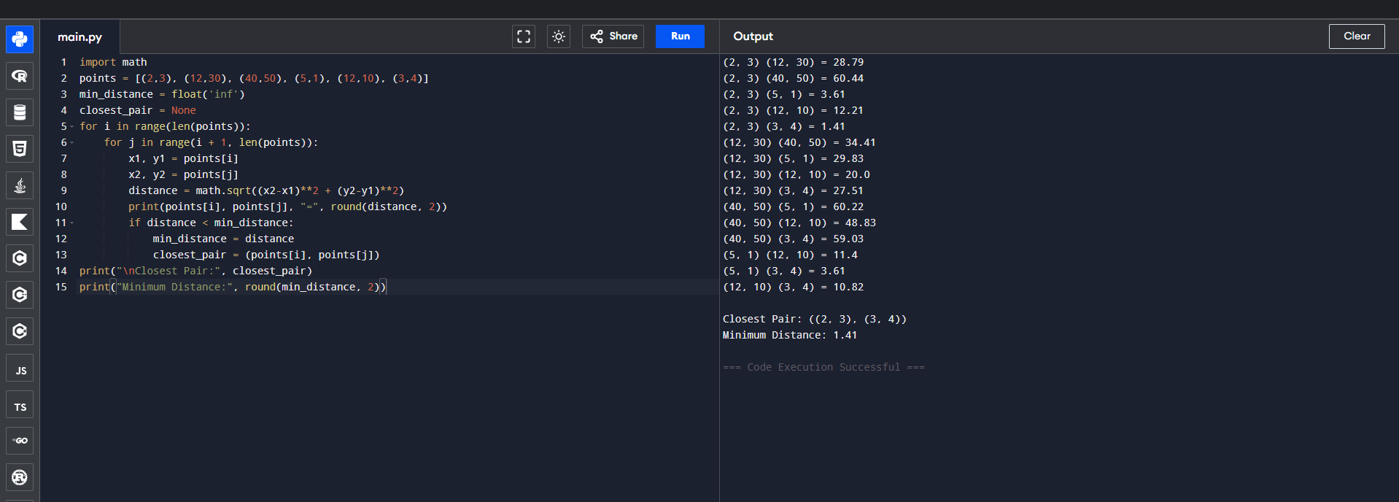
2. Sorting Techniques – Comparative Pass Analysis
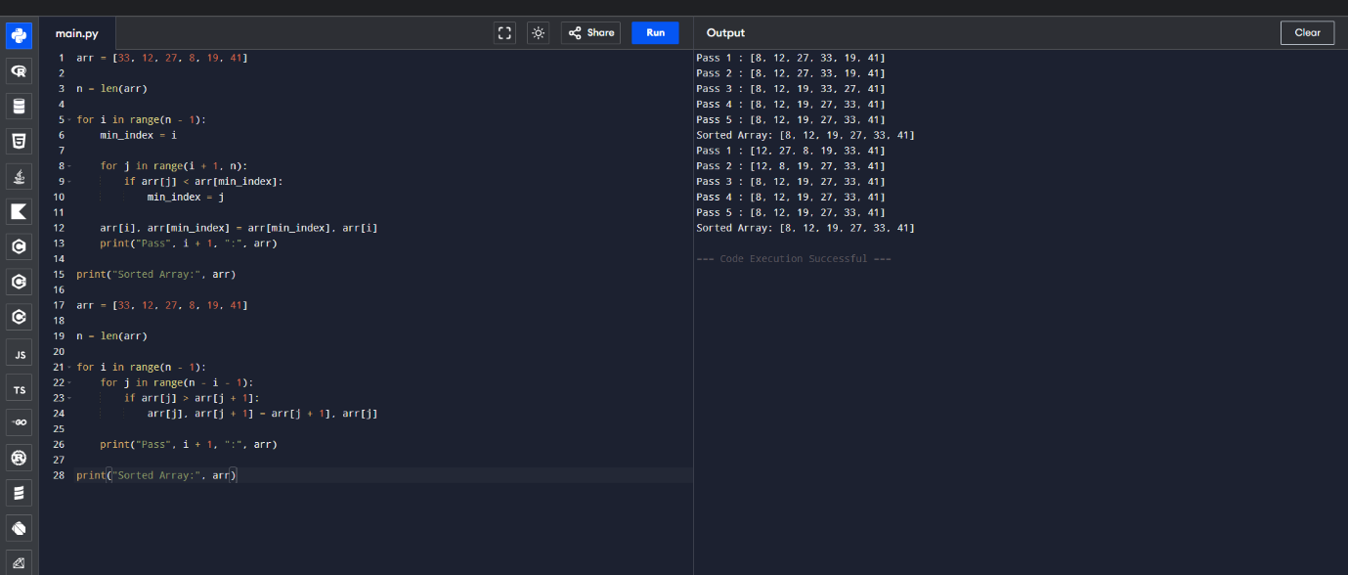
3. Binary Search – Upper Half Ordered Search